***Contents:***

**Introduction:** 2

**1.** **Biblical Origin:** 2

**2.** **Religious Significance:** 2

**3.** **Modern Observance:** 3

**4.** **Eastern and Oriental Christianity** 3

**5.** **Western Christianity** 3

**6.** **Conclusion:** 3

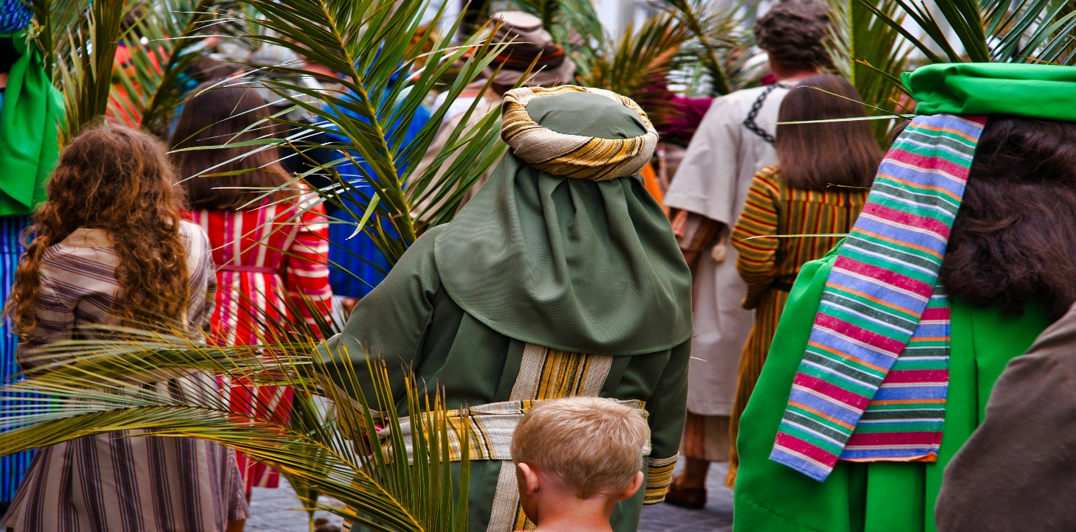

**History Of Palm Sunday.**

# **Introduction:**

Palm Sunday is a significant Christian holiday that marks the beginning of Holy Week — the final week of Lent leading up to Easter. It is celebrated on the Sunday before Easter and commemorates Jesus Christ’s triumphant entry into Jerusalem.

# **Biblical Origin:**

The event is described in all four Gospels (Matthew, Mark, Luke, and John). As Jesus entered Jerusalem, crowds gathered to welcome Him by spreading palm branches and cloaks on the road, shouting "Hosanna! Blessed is He who comes in the name of the Lord!"

Palm branches were a symbol of victory and peace in Jewish tradition, and the act symbolized the people recognizing Jesus as the promised Messiah.

## **Religious Significance:**

Palm Sunday marks the fulfillment of the prophecy from the Old Testament (Zechariah 9:9) that the Messiah would come humbly, riding on a donkey. It sets the stage for the Passion of Christ, which includes His suffering, crucifixion, and resurrection.  
For Christians, Palm Sunday is both a joyful and solemn day — joyful in the celebration of Jesus as King, and solemn because it leads to His crucifixion later in the week.

## **Modern Observance:**

Today, Christians around the world commemorate Palm Sunday by attending special church services. Palm leaves are often distributed to worshippers and carried in processions. In some churches, the palms are later burned and used to make ashes for Ash Wednesday of the next Lent.

## **Eastern and Oriental Christianity**

Small crosses woven from blessed palms are often distributed at churches on Palm Sunday. Palm Sunday, or the Entry of the Lord into Jerusalem as it may be called in Orthodox Churches, is one of the Twelve Great Feasts of the liturgical year. The day before Palm Sunday, Lazarus Saturday, believers often prepare palm fronds by knotting them into crosses in preparation for the procession on Sunday. The hangings and vestments in the church are changed to a festive color – most commonly green.

## **Western Christianity**

Palm Sunday procession in Toledo, Spain Palm Sunday in East Timor Palm Sunday in Averna, Italy in ancient times, palm branches symbolized goodness and victory. They were often depicted on coins and important buildings. Solomon had palm branches carved into the walls and doors of the temple.[33] Again at the end of the Bible, people from every nation raise palm branches to honor Jesus.

## **Conclusion:**

Palm Sunday is a powerful reminder of Jesus' humility and the beginning of His final journey toward the cross. It holds deep spiritual significance, marking both the hope of salvation and the sacrifice that was made to achieve it.